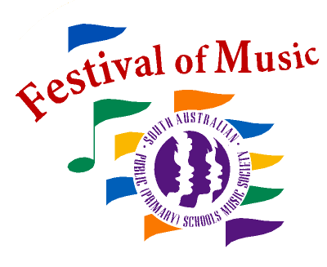
Associate Affiliation Details
ABN 16 350 530 496

1
Festival of Music 2020 – Associate Affiliation
Please print neatly.
School Name
Address
Suburb & Postcode
Choir Teacher | □ unknown
Email
Will Choir Teacher be attending Conference on 6th- 7th Feb 2020? | Yes No
Principal Name
Email
School Phone
School Fax

If you would like to send staff other than your Choir Teacher and Accompanist to conferences, please contact us in advance for catering purposes. You will receive a separate invoice after the conference – please do not add the charge to your affiliation payment.
Fees for extra personnel are as follows:

Day | Fee*
Conference 1 - Thursday 6th February 2020 | $140.00
Conference 1 - Friday 7th February 2020 | $190.00
Conference 1 - Friday 7th February 2020 (Choir Support morning session only) | $65.00
Conference 2 – Friday 8th May 2020 | $140.00

* All charges attract 10% GST
Checklist

CHEQUE or EFT RECEIPT stapled at the front, payable to: SAPPS Music Society Inc.
PAGE Associate Affiliation Details AND PAGE Associate Affiliation Order
Keep a copy for your own records.
In an envelope addressed to: Primary Schools’ Music Festival, 28 Hay Street, Klemzig SA 5087
TO ENSURE NO BREACH OF COPYRIGHT, PLEASE CONTACT domusic.psmf448@schools.sa.edu.au
BEFORE COPYING, PERFORMING OR RE-ARRANGING
Associate Affiliation Order
Tax Invoice ABN 16 350 530 496

2
SA PUBLIC (PRIMARY) SCHOOLS MUSIC SOCIETY INC.
School:________________________
Item |  | #No. | $Total
Affiliation Fee - Earlybird |  | Choose which ever is applicable | $345.00
Affiliation Fee (23 November - 13 December) |  |  | $395.00
Affiliation Fee (after 13 December) |  |  | $445.00
Piano Accompaniments @ $75 set
Rehearsal Revivers @ $30
DVD and book of music and drama games/songs
30 Songs in 30 Minutes @ $16
30 Warm-ups with Piano CD
Student Learning Materials
*Please note that songbooks and CDs cannot be purchased separately.
Songbook and Soprano CD* @ $16
Songbook and Soprano Learning Portal access* @ $16
Songbook and Alto CD* @ $16
Songbook and Alto Learning Portal access* @ $16
Performance and Backing Double CD @ $16
EFT Payment  Account Name: SAPPS Music Society  BSB: 065 141  Account No 10272582  Reference: AffilSchool (eg. AffilBarmera)  Please email remittance and affiliation paperwork to office.psmf799@schools.sa.edu.au | SUB-TOTAL |  | $
 | ADD 10% GST |  | $
 | ENCLOSED CHEQUE  Payable to SAPPS Music Society Inc. |  | $

Purchase of these materials is an undertaking to abide by copyright restrictions.
No affiliation will be processed without payment. Earlybird due date 22/11/19 (Friday, Week 6, Term 4).

PSMF Office Use Only
EFT/Cheque Received | Entered in Database | Packed and Sent

