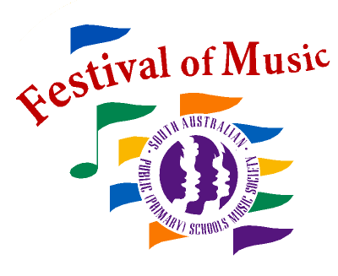
Associate Affiliation Details
ABN 16 350 530 496

1
Festival of Music 2021 – Associate Affiliation
Please print neatly.
School Name
Address
Suburb & Postcode
Choir Teacher | □ unknown
Email
Principal Name
Email
School Phone
School Fax

If you would like to send staff other than your Choir Teacher and Accompanist to conferences, please contact us in advance for catering purposes. You will receive a separate invoice after the conference – please do not add the charge to your affiliation payment.
Fees for extra personnel are as follows:

Conference | Charge*
Conference 1: Thursday 4th February – Friday 5th February | $380.00
Conference 2: Friday 7th May | $200.00

* All charges attract 10% GST

TO ENSURE NO BREACH OF COPYRIGHT, PLEASE CONTACT domusic.psmf448@schools.sa.edu.au
BEFORE COPYING, PERFORMING OR RE-ARRANGING

Associate Affiliation Order
SA PUBLIC (PRIMARY) SCHOOLS MUSIC SOCIETY INC.
Tax Invoice ABN 16 350 530 496

2

School:________________________

Item |  | Qty | $Total
Affiliation Fee – Earlybird (by 20 November 2020) |  | Choose which  ever is applicable | $380.00
Affiliation Fee (after 20 November 2020) |  |  | $480.00
Piano Accompaniments @ $80 set
Student Learning Materials include a Songbook and access to the PSMF Learning Portal
and Festival of Music App

Please order a minimum number of materials to avoid additional processing fees.

Student Learning Materials @ $20
Performance and Backing Double CD @ $20
EFT Payment  Account Name: SAPPS Music Society  BSB: 065 141  Account No 10272582  Reference: AffilSchool (eg. AffilBarmera)  Please email remittance and affiliation paperwork to office.psmf799@schools.sa.edu.au | SUB-TOTAL |  | $
 | ADD 10% GST |  | $
 | TOTAL |  | $

Purchase of these materials is an undertaking to abide by copyright restrictions.
No affiliation will be processed without payment.
Earlybird due date 20/11/20 (Friday, Week 6, Term 4).

PSMF Office Use Only
Payment Received | Entered in Database | Packed and Sent

