NOTICE OF ANNUAL GENERAL MEETING

Wednesday 27 March 2024 – 4.30pm
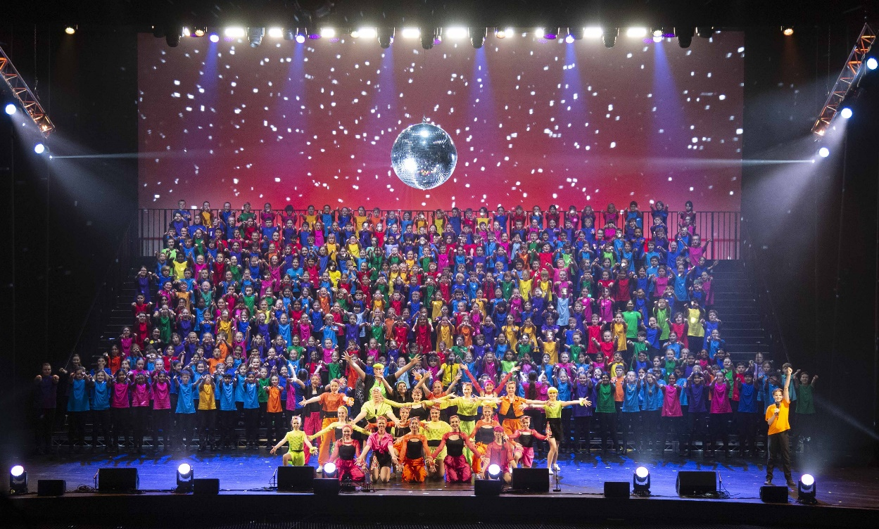

Notice of the South Australia Public Primary Schools Music Society Ltd. Annual General Meeting. We are presenting our AGM information in a hybrid format (in-person or virtual attendance).
Details on how to register are attached as well as our, Appointment of Proxy Form and Nomination Form.
Reports and Financial Statement will be on the website 7 days prior to the AGM.

NOTICE OF ANNUAL GENERAL MEETING
Wednesday 27 March 2024

Hybrid (in-person or virtual attendance) Meeting – 4.30pm
Virtual attendees must register by contacting our office
Tel: 8261 5438
Or email: info.psmf528@schools.sa.edu.au

Registration Deadline: Wednesday 20 March 2024

AGENDA
Welcome by President: Terena Pope
Present:
Apologies:
Confirmation of minutes of the previous SAPPSMS AGM - held on 30 March 2023
Reports
- President: Terena Pope
- Manager: Irene Solowij
- Director of Music: Robyn Filmer
- Treasurer: Kirsty Henning
- Choir Teacher / HPI Representative: Kendall Hurst
- The SAPPS Choir Administrator: Joanne Kay
General Business
- Election of Life Members
- Appointment of Auditor
Election of Music Society Board Directors
- Up to seven (7) School-based Leaders
- Choir teacher / HPI Representative
- Up to two (2) additional Music Society members

