Site name
Pick up location, destination, method and means of transport (including proposed route)
Date and time of departure/return e.g. from the site to each destination and returning to the site
Proposed activities | Festival of Music rehearsals and performance
Class and year level
Number of children/ young people
Number of employees/ volunteers

Key contacts |  | Name |  | Contact No
Site leader
Teacher-in-charge/responsible person
Alternative teacher contact
Health and safety representative
Site point of contact
First aider |  | First Care Medical
APPROVAL
Acknowledgement: Safety risks have been identified for the listed camp / excursion with controls implemented to effectively manage risks to the health and safety of participating employees, volunteers, children, and young people.
Requirements in this document must not be altered and it must be available at the site for parent inspection requests. This form must be completed to ensure compliance with the Education and Care Services National Regulations and departmental policy before seeking parent/legal guardian consent and before a camp or excursion takes place.
Position | Name |  | Signature |  | Date
Teacher-in-charge
Site leader

Minimum requirements
Planning | - 1 teacher is assigned as the teacher-in-charge, as the delegate of the site leader, to provide leadership and control of the camp or excursion.  - The venue for excursion or camp location is reviewed in the initial planning stage to determine the suitability of location. The location must have an emergency management plan.  - The emergency management plan in this form is reviewed and updated, if required.  - For a sporting or adventure activity, the sporting and adventure activities standard and activity instructions must be followed; the instructor competency and supervision ratios must be adhered to.  - A parent or guardian signs the excursion/camp consent form.  - Weather forecast to be checked leading up to and during the camp/ excursion.  - Monitoring of CFS bushfire alerts and special consideration for camps in bushfire prone areas. Cancel the camp/excursion if the destination is in a bushfire prone area during an extreme fire danger warning, a total fire ban or if there is a bushfire.  - Ensure appropriate communication devices with adequate service coverage are available.  - For activities without a prescribed ratio, or the risk assessment does not indicate a higher ratio is required, the minimum supervision ratios are in place:  - 1:6 for preschools to year 2  - 1:10 for years 3-7  - 1:15 for years 8-12.  - Ensure there is adequate supply of water and food, sun protection and appropriate clothing for weather conditions.  - List of children and adults attending the camp/excursion and contact information for each person.
Conduct and behaviour | - Children and young people follow the school behaviour code.  - Supervisory staff team members follow the Code of Ethics for the South Australian Public Sector.  - Supervisory volunteer team members follow the Expected Behaviours for Volunteers, outlined in the Volunteer Agreement.  - All supervisors, including parents, volunteers and instructors must hold a child related screening clearance in accordance with the Screening and suitability (child safety) policy.  - Volunteers have met screening and suitability requirements, completed an induction and are aware of the protective practice guidelines.  - All participants are briefed on any identified conditions of the children/young people, the emergency and contingency plans, any relevant specialized or technical skills of supervisory team members, their roles and responsibilities and any relevant hazards.  - Children and young people are accounted for at regular intervals; with a head count occurring each time children/young people board and disembark transport; and enter and leave the location, checked against the attendance record.  - Alcohol or drugs must not be consumed; and supervisors must not smoke within 10 meters of the camp perimeter or in view of children/young people.
First aid | - For camps and adventure activities 1 person is trained in ‘HLTAID004 – emergency first aid in education and care settings’ for every 25 people.  - Where it may take greater than 2 hours for medical assistance or a medical retrieval to arrive, at least 1 first aider must be trained in ‘HLTAID005 –first aid in remote situations’.  - For excursions, consider the risks of the location or activity being undertaken; and any pre-existing medical conditions of the participants. Ensure that you have one of the following:  - a designated first aider in the group  - a teacher trained in first aid  - a first aider available at the location  - access to local area GP/medical facilities  - a paramedic in close proximity.  - Appropriate type of first aid kits is available e.g. basic first aid kit for each first aider, remote first aid kit, Epi-Pen etc.  - The first aiders have a copy of any individual first aid plan where a child or young person has a known health condition and the first aid response is NOT the standard first aid response for that health condition.  - Medications required for children and young people must be easily accessible and secured to prevent unauthorised use.  - Leadership team provided with medical information for each child (where applicable).  - Children and young people with complex and invasive health needs must be provided with the opportunity to attend camps/excursions and be supported by a competent person to manage their health needs.
Transport | - The bus is fitted with a current safety label (safety triangle on windscreen) and the bus driver holds a valid licence.  - The bus company has a contingency plan in the event of mechanical failures.  - Check no one is left on a bus by walking the length of the bus and conducting a visual inspection including checking under seats.  - Private motor vehicles are used as a last resort with a written agreement signed prior to the event (use the agreement form and employees also must complete ED008) and parental consent sought.  - Driver’s licences are unrestricted and valid; “L” plate drivers are not to transport children or young people.  - Complete a long distance travel plan if an employee is driving greater than 300kms in a rural location.  - Requirements for seatbelts or safety restraints when transporting children are implemented as required  - For education and care services, ensure there is a process for entering and exiting the service and the pick-up location or destination (as required) and procedures for embarking and disembarking the means of transport.

Follow the steps on page 4, and in the table below list any additional hazards and controls for your sport, adventure, camp, and excursion that are not already listed on page 2 of this document. The safety requirements outlined in the camps and excursions intranet and the sporting and adventure activities intranet identify further hazards and controls that may also need to be considered.
NOTE: Early childhood sites must identify and address all water hazards.
Sports, adventure, camps and excursions risk assessment for additional hazards
Hazard identification  (What is the issue of concern?) | Risk Controls  (What are you doing to eliminate or reduce the risk?) | Risk (With all controls in place)
E.g. School camp includes student archery activities | - Archery sporting instructions followed (Activity category list) – Category 2 activity  - Qualified instructors available. | Med
Students and staff from schools walking from outside to the rehearsal space  Students and staff from schools walking from the rehearsal space up on to the stage area  Slip or fall on stage | - Children are supervised and directed to walk, stay in lines and to move in an orderly manner.  - All doorways and corridors clear in order to move freely  - Both adults and children use the side handrail when climbing up onto the choir staging  - All cords are taped and secured  - Choir will be sitting on individual interlocked and sturdy seats | LOW
Fall while standing on the stage area  Collapse of staging  Unauthorised students or adults entering line up area, rehearsal space or stage area | - Children are closely supervised while standing on the stage area and instructed as to how to sit and stand  - Stage manager to inspect correct construction of staging has been completed prior to being used for rehearsal/performance. Documentation from engineer provided demonstrating that Australian Standards are met.  - Comprehensive pass system in place, all approved personnel who work with students to have appropriate screening. Security on all access points with PSMF Security, visual boundaries to public and non-public areas | LOW
Child may wander off/ go missing while moving to the hold, to stage or when leaving the arena | - Children supervised at all times by suitably screened adult  - Dismissal procedures clearly outlined  - Children briefed at both rehearsal and performance about expectation and what do if lost | LOW
Emergency procedures – communication of information | - All Production personnel and in contact through headset radios.  - AEC communication processes in place for emergency action required. | LOW
Object falling from rigging | - All rigging set to industry guidelines by trained staff and checked before performance | LOW
Child/adult fainting becoming distressed  Removal of child from rehearsal/performance stage | - Teachers will be on stage to watch and check on their students  - Children instructed prior to performance- what to do in the case of illness, feeling faint etc. and how to prepare beforehand. First Care Medical trained Paramedics in Sick Bay near stage.  - Children with identified medical needs are known by Concert Manager (CM) and their Health Plans are given to “First Care Medical” personnel in attendance (e.g.: asthmatic or diabetic etc.)  - First Care Medical are fully qualified paramedics or nurses | MEDIUM  LOW
Security Threat | - Refer to AEC document re audience security and Production Evacuation Document (available from PSMF)  - Generally follow AEC staff instruction in any emergency situation. | LOW
Travel accident | - All passengers to use seatbelts (if installed) and not distract driver  - If something occurs, contact emergency services and school leadership for further instructions | LOW
Vehicle breakdown | - Reliable vehicle to be used for transport  - If something occurs contact school leadership/Music Festival leadership to advise families/PSMF of possible delay | LOW

Sports, adventure, camps and excursions risk assessment for additional hazards
Step 1: Have a look at WHS safety management intranet and see if there are any activity hazards that are not already covered.
Step 2: Identify controls for your remaining hazards. Use the hierarchy of control chart to help select controls that provide the highest level of protection to employees and participants

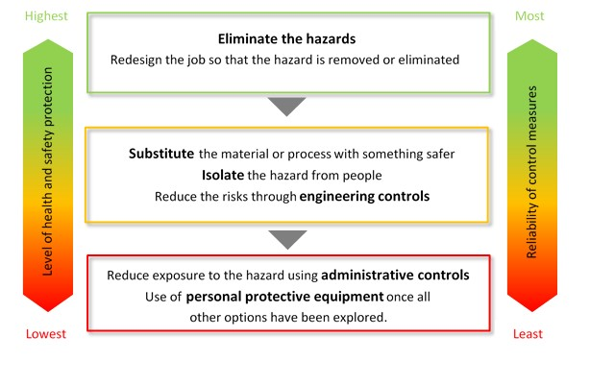

Step 3: Assess the risk of the identified hazard assuming all controls are in place
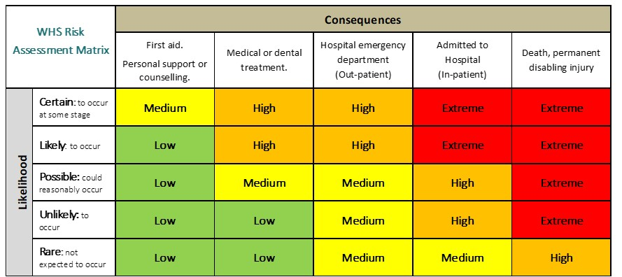

Step 4: Check the assessed risk level and undertake the associated action.

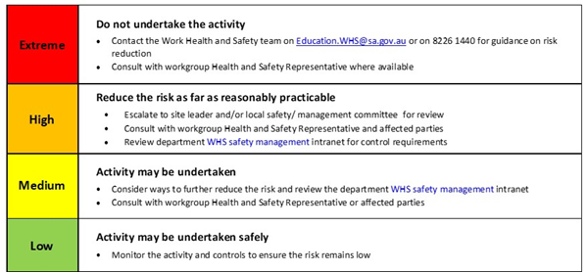

Other items that should be taken on the camp/excursion
List any other items (in addition to the minimum items listed above) that will be needed on the camp or excursion

Emergency management plan
- Provide immediate first aid assistance or care prescribed by an individual health support plan and/or isolate any person with an infectious disease.
- Call 000 and advise them of the closest vehicle entry point.
- Ensure communication with emergency services is maintained.
- Send an employee or volunteer to the point where emergency services will enter the location, if it is safe to do so.
- Collect the attendance list, individual first aid plans and this plan.
- Evacuate all people to the nominated emergency assembly point.
- Once at the assembly point, check all people are accounted for.
- Maintain a record of actions/decisions undertaken and times.
- Report the emergency/evacuation to the site leader of the school or preschool by using the agreed form of communication tool i.e. mobile phone.
- Site leader will then notify:
- Education Director
- Report on IRMS as a notifiable incident.
- Wait for emergency services to arrive or provide further information/instruction.
- Teacher in charge to arrange for parents to be informed.
Note method for communicating with the school/preschool contact:
The school/preschool contact must be contactable at all times, have a copy of this risk management form, be aware of the emergency management plan, have the attendance lists, child/young person health and personal care information, contact numbers of parents/legal guardians, and the itinerary.
Note nearest suitable transport:
Note distance from help and method for obtaining it:
List any additional contingencies (i.e. in the event a person becomes lost):
Contact numbers for PSMF staff:
Manager: Irene Solowij 0432 816 319 (Irene)
Production Manager: Anne O’Dea 0407 747 401 (Anne)

Call-in procedure
The following process must occur when the camp or excursion is in a remote or isolated location.
- The teacher-in-charge or delegate must contact a designated person at the site to inform them they have safely arrived; and call prior to leaving the camp or excursion location with an estimated time of arrival back at the site.
- The teacher-in-charge must provide a time that the check-in will occur.
- If the check-in does not occur after 20 minutes of the agreed time, the site designated person must phone the teacher-in-charge or an alternative contact.
- Once 2 unsuccessful attempts have been made to contact the teacher-in-charge or alternative contact within 30 minutes the designated person at the site must inform the site leader and call 000 for police assistance.

Emergency management map for your remote or isolated destination
The below map is not required in built-up residential areas. It is only required when an ambulance station is not within 30kms of the camp or excursion location. You must include as indicated in your emergency management plan the emergency vehicle access point and the emergency assembly point.

GPS coordinates
Plus code: ; or
Latitude: Longitude:

Remote or isolated location:
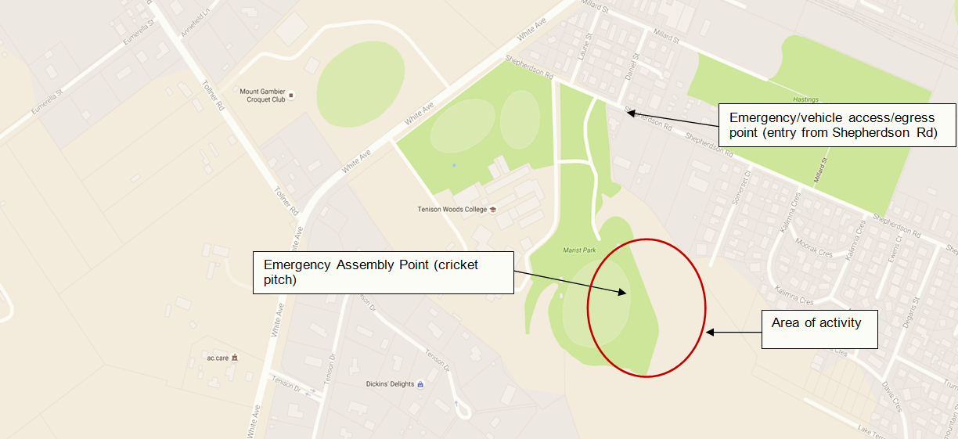
Note: Obtain your site map through Google Maps by searching for your destination; press “Alt + PrtScn” buttons on your keyboard (this will copy the map to your clipboard); click the sample map above and press “Ctrl + V” to insert your new map.
Use the “text Box” function to identify key points such as “Emergency Assembly Points” and “Activity area” etc.

