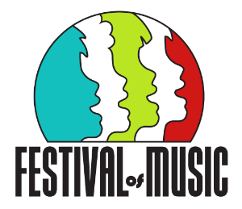

Group Media Consent This form is for SCHOOL GROUPS only.

Please ensure that forms are checked and completed correctly by parents/caregivers. The forms are held at your school.
We do not require the forms to be sent to us.

Name of School:___________________________________________________
Concert No: _____

The following students have not yet completed the Department for Education and/or PSMF media consent forms.
_______________________________
_______________________________
_______________________________
_______________________________

I ensure that the ‘Permission to use, video, voice, and/or creative work of students and children’ there is parental/caregiver consent for each student’s performance to be recorded.

Choir/Support teacher name: _______________________________________
Signature: _______________________________________ Date: __________

