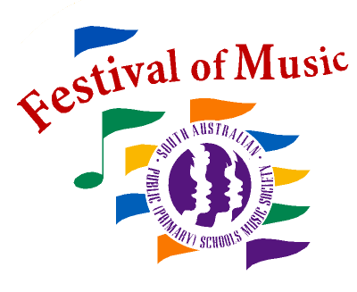
Supplementary Order 2020
Tax Invoice ABN 16 350 530 496

Name:
School:
Street: | Suburb and Postcode:
School Phone Number: | School Fax Number:
Circle Affiliation Type/Location: Adelaide Associate Affiliation Southern Metro Northern Metro Eyre
East of Ranges Murray Mallee Port Augusta Port Pirie Riverland South East Whyalla Coober Pedy

Item |  | #No | $Total
Songbook and Soprano CD $16.00
Songbook and Soprano Learning Portal Access $16.00
Songbook and Alto CD $15.00
Songbook and Alto Learning Portal Access $16.00
Performance and Backings Double CD $16.00
Rehearsal Revivers $30.00
DVD and book of Fun and Action Songs, Music and Drama Games
30 Songs in 30 Minutes $16.00
30 Warm-ups with piano CD
Accompanist Score $75.00
FOM Lanyard $3.64
FOM Wristband $1.82
FOM Lead Pencil $0.91
Packing and Postage (N/A if picking up from Klemzig PS) |  | Cross out $ if picking up from PSMF office | $9.00
EFT Payment  Account Name: SAPPS Music Society  BSB: 065 141  Account No 10272582  Reference: SuppSchool (eg. SuppBlyth)  Please email both remittance and order form to office.psmf799@schools.sa.edu.au  Do not post originals | SUB-TOTAL |  | $
 | ADD 10% GST |  | $
 | TOTAL |  | $

Purchase of these materials is an undertaking to abide by copyright restrictions.
PSMF Office Use Only
EFT/Cheque Received | Entered in Affiliation Database | Packed and Sent

